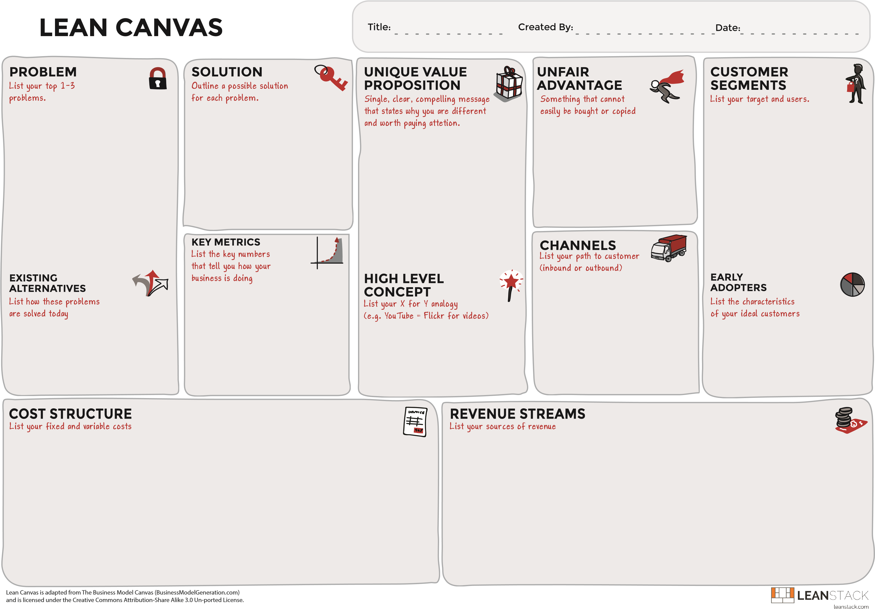
We license to manufacturers and OEMs, and they use the turbines as engines in their products that they sell to consumers and/or other businesses.
All of transportation: Road, off-road, shipping, air vehicles.
Utility Motors: Generators, Mowers, chainsaws, yard tools, etc.
Power plants using fossil fuels.
Homeowners
Turbine with few moving parts: rotor and 2 bearing sets. Keeps working fluid inside rotor until maximum energy extracted.
Engine manufacturers
Aftermarket engine suppliers
Vehicle manufacturers
Patented, so we are protected.
Design is easy to understand, generates enthusiasm for it quickly.
Piston Engines
Axial Turbines
Radial Turbines
Cheap to manufacture
High efficiency
Few moving parts
Extremely durable
Power in a small package
Fuel flexible
Cost Category | Cost
Personnel | $2,745,900.00
Facilities | $369,160.00
Hardware | $121,468.44
IT | $79,680.00
Materials | $73,835.60
Marketing | $142,000.00
Other | $87,150.00

Royalties (Primary incime)
Time and Materials Charges from Helping Customers Set Up Production
In Some Cases, We May Work with Customers to Create New Turbine Products for Resale
Number of customers
Turbines created/month
Royalties collected/month
We have invented a turbine that is cleaner and simpler than piston engines, more compact and easier to build than most turbine motors, and potentially more efficient and higher energy density than either.
Piston engines are dirty, inefficient, and have too many moving parts to break.
Turbines are loud, thirsty and huge.
US CAFÉ numbers in some cases have exceeded piston engines’ capacity
10/09/2020
Carl Kemp
StewardTech Turbine

